How to use the meeting room in Outlook, here comes some tips, hope can help you to fast get it. ☺

- Create a meeting in outlook


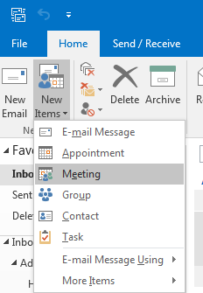

- Click Rooms


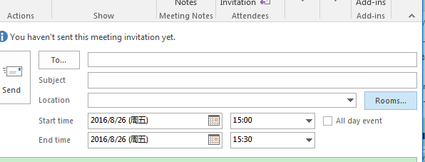

- Choose CN-Room1, and click OK


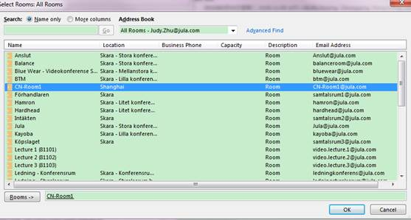

- CN-Room1 shows in “To” and “Location”


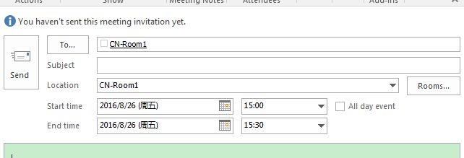

- You will receive an accepted email from CN-Room1 after invitation out.

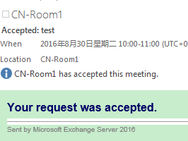

- Go to Calendar, open Calendar, choose ”From Room List”, locate CN-Room1, press OK





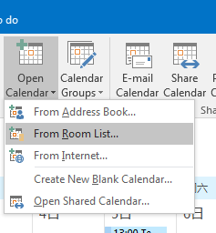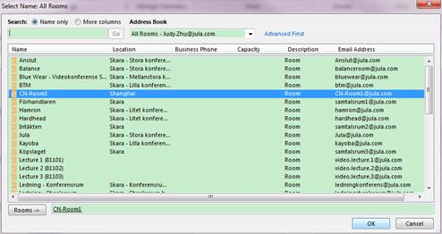

- Back to the Calendar View, you’ll see the CN-Room1 has been added to “ROOMS” group in the left navigation pane. You will see the bookings on it.



